1a)

U = [[1,1,-sqrt(2),0],

[-1,1,0,-sqrt(2)],

[1,1,sqrt(2),0],

[-1,1,0,sqrt(2)]] / 2

S = [[2sqrt(2), 0, 0],

[0, 2, 0],

[0,0,0],

[0,0,0]]

V = [[0 , 1. ,0],

[1/sqrt (2), 0, 1/sqrt(2)],

[-1/sqrt(2), 0, 1/sqrt(2)]]

Note that this is not unique

l_2 norm is 2sqrt(2)

1b)

a = b = h =1

The trick is to add a new column with all value equal to 1 so that we can compute h

Let M = matrix of data, x = model and b = observed values. With this data they look like this (wolfram notation because I don’t know how to put a matrix here):

M = { {1,-1,1}, {-1,1,1}, {1,1,1}, {-1,-1,1} }

x = {a, b, h}

b = {-1, -1, 5, 1}

To see why this holds, just multiply Mx and you get 4 equations, each corresponding to one row of the data. Now we want to minimise error of Mx=b. We can do that by solving $M^{T}Mx=M^{T}b$.

M^T M = { {4,0,0}, {0,4,0}, {0,0,4} }

M^T b = {4,4,4}

Which resolves to system of three linear equations:

4a = 4; 4b = 4; 4h = 4

1c)

Q = 1/sqrt(2) * { {-1, 1}, {1, 1} }

R = {{sqrt(2), sqrt(2)}, {0, 4 * sqrt(2)}}

1d)

To prove rank the same see previous answer

Idea is to prove null(A) = null(A^T A) [link to math stackexchange for this](https://math.stackexchange.com/questions/349738/prove-operatornamerankata-operatornameranka-for-any-a-in-m-m-times-n)

And the use rank nullity theorem to show that

rk(A) = rk(A^T A)

And similarly we have

rk(A^T) = rk(A A^T)

And since rk(A) = rk(A^T)

We have the expected result

1e)

to proof the modulus of eigenvalue is 1 we observe that orthogonal transformation doesn't change the norm so we have that the modulus of Eigenvalue is 1.

Let the eigenvector be x and the eigenvalue be c and we have

Ax = cx

Take the norm:

The norm of Ax = the norm of cx

By the property of norm

the norm of cx = absolute value of c * the norm of x

Since orthogonal transformation doesn’t change the norm, we have:

absolute value of c * the norm of x = the norm of x

So the absolute value of c is 1

2a)

16 * 318/132 = 38.5

2b)

Choose l_infinity norm and it is similar to the one in slide

2c)

Don’t forget to wirte the definition of laplace transformation

And show the laplace transformation of e^-lambda t

i)

Same as in slide

ii)

y1(t) = 5e^ -10t

y2(t) = 2e^-10t

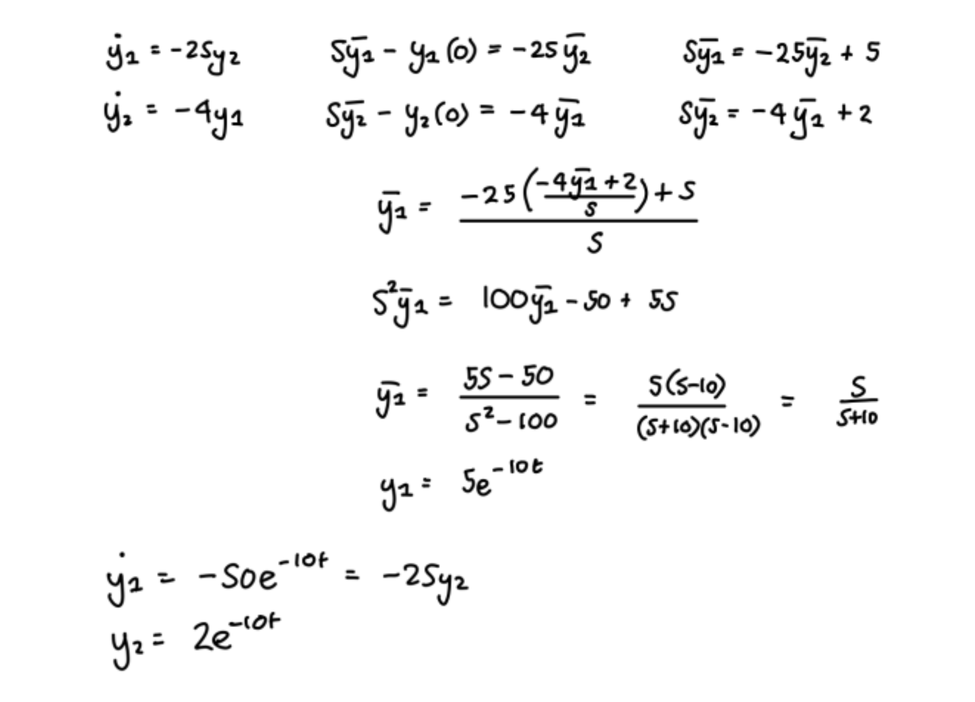

*[2022 – Added working bc I forgot how to do these]*

2d)

i) (0,0) - hard to say (H = 0) => Notice that its f(x,y) >= 0, only being 0 at (0,0). Hence it is a minimum.

ii) (0, -3) - minimum, (0, ⅓) - saddle

iii) (0,0) - saddle, (-⅙, 1/12 ) - minimum,